**Computer Networks**

**Lab 5**

**Wireshark Lab:IP v8.0**

**Student Name: Phạm Ngọc Sang**

**Student No: 1813810**

1. **What is the IP address of your host? What is the IP address of the destination host?**

Answer:

My IP address: 192.168.0.104

Ip address of the destination host: 143.89.12.134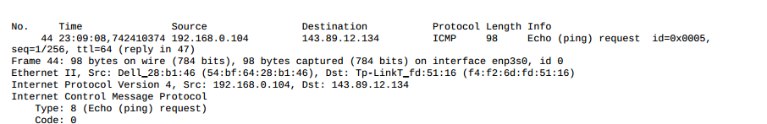

1. **Why is it that an ICMP packet does not have source and destination port numbers?**

Answer:

This is Transport Layer so we do not need source and destination port

1. **Examine one of the ping request packets sent by your host. What are the ICMP type and code numbers? What other fields does this ICMP packet have? How many bytes are the checksum, sequence number and identifier fields?**

Answer:

Type: 8

Code: 0

The other fields:

Checksum

Identifier (BE)

Identifier (LE)

Sequence number (BE)

Sequence number (BE)

Each field contains 2 bytes

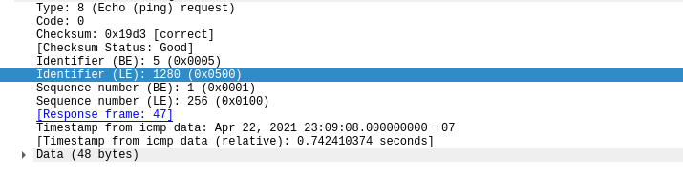

1. **Examine the corresponding ping reply packet. What are the ICMP type and code numbers? What other fields does this ICMP packet have? How many bytes are the checksum, sequence number and identifier fields?**

Answer:

Type: 0

Code: 0

The other fields:

Checksum

Identifier (BE)

Identifier (LE)

Sequence number (BE)

Sequence number (BE)

Each field contains 2 bytes

1. **What is the IP address of your host? What is the IP address of the target destination host?**

Answer:

My host ip: 10.28.129.102

Destination host ip: 128.93.162.63

1. **If ICMP sent UDP packets instead (as in Unix/Linux), would the IP protocol number still be 01 for the probe packets? If not, what would it be?**

Answer: No.If ICMP sent UDP packet, IP protocol number is 0x11

1. **Examine the ICMP echo packet in your screenshot. Is this different from the ICMP ping query packets in the first half of this lab? If yes, how so?**

Answer: ICMP echo packet has fields same as ping query packets

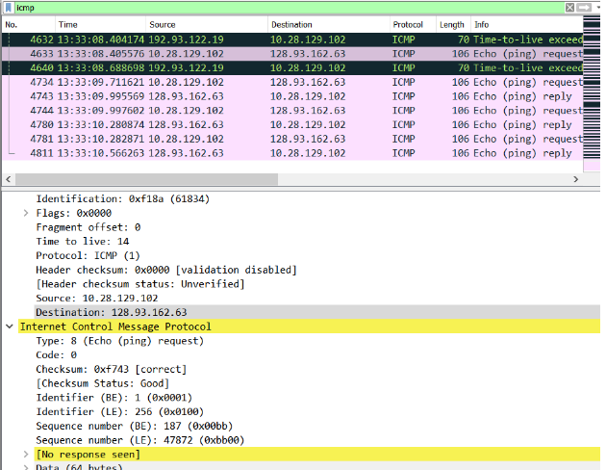

1. **Examine the ICMP error packet in your screenshot. It has more fields than the ICMP echo packet. What is included in those fields?**

Answer: contains the header and the original 8 bytes of the ICMP packet that the error was for

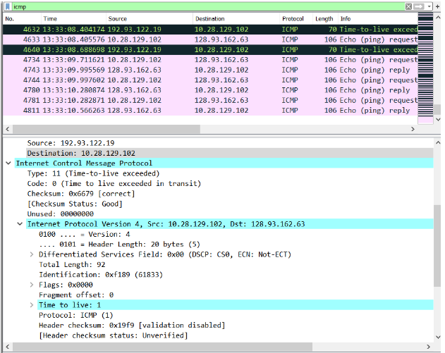

1. **Examine the last three ICMP packets received by the source host. How are these packets different from the ICMP error packets? Why are they different?**

Answer: type: 0 (echo reply). Differ because datagrams have arrived before the TLL expires.

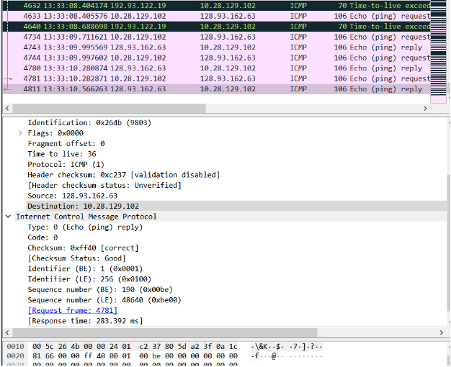

1. **Within the tracert measurements, is there a link whose delay is significantly longer than others? Refer to the screenshot in Figure 4, is there a link whose delay is significantly longer than others? On the basis of the router names, can you guess the location of the two routers on the end of this link?**

Answer:

link between tep 9 and 10 has a high delay. This step may be between 2 countries. Based on router names we can guess that are Singapore and France

